**DAY-10 ASSIGNMENT**

**NAME: SUDHA SREELATHA**

**EMP ID: 46255249**

**Assignment 3 – Business Add in (BADI)-Single Use**

**Hint:**

1. **SE18 should be used to define a** **BADI**
2. **SE19 should be used to implement the BADI Definition.**

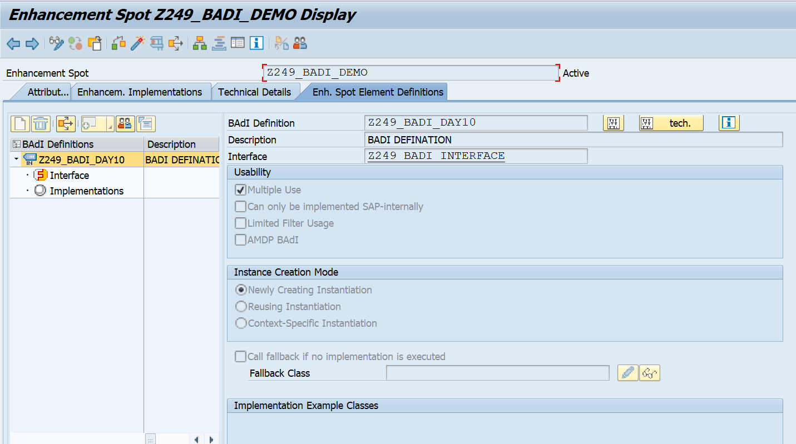

**CODE:**

*&---------------------------------------------------------------------*  
*& Report Z249_DEMO_BADI  
*&---------------------------------------------------------------------*  
* Description:                                                         *  
*                                                                      *  
* Author:                                                              *  
*                                                                      *  
* Create date:                                                         *  
*                                                                      *  
*&---------------------------------------------------------------------*  
* Modification log:                                                    *  
* -------------------------------------------------------------------- *  
* Date        User name      ID       Change Request   Case ref.       *  
*             Description                                              *  
*&---------------------------------------------------------------------*  
REPORT Z249_DEMO_BADI.  
PARAMETERS: NUM1 TYPE I,  
            NUM2 TYPE I.  
DATA RES TYPE I.  
DATA OBJ TYPE REF TO Z249_BADI_INTERFACE.  
  
CALL METHOD CL_EXITHANDLER=>get_instance  
  EXPORTING  
    exit_name                     = 'Z249_BADI_INTERFACE'  
  CHANGING  
    instance                      =   OBJ  
  .  
IF sy-subrc <> 0.  
  MESSAGE 'Error while calling method' TYPE 'I'.  
ENDIF.  
*CALL METHOD OBJ->divide  
*  EXPORTING  
*    i_num1      = NUM1  
*    i_num2      = NUM2  
*  IMPORTING  
*    e_result    = RES  
*  EXCEPTIONS  
*    div_by_null = 1  
*  .  
CALL METHOD OBJ->DIVIDENUMBERS  
  EXPORTING  
    I_NUM1    = NUM1  
    I_NUM2    = NUM2  
  IMPORTING  
    E_RESULT  = RES  
  EXCEPTIONS  
    NULLVALUE = 1  
    OTHERS    = 2  
  .  
IF SY-SUBRC <> 0.  
 MESSAGE ID SY-MSGID TYPE SY-MSGTY NUMBER SY-MSGNO  
            WITH SY-MSGV1 SY-MSGV2 SY-MSGV3 SY-MSGV4.  
ENDIF.  
IF sy-subrc = 1.  
  MESSAGE 'Division by zero' TYPE 'I'.  
ELSE.  
    WRITE:/ 'NUM 1 IS : ' , NUM1.  
    WRITE:/ 'NUM 2 IS : ' , NUM2.  
    WRITE:/ 'RESULT IS : ' , RES.  
ENDIF.

**OUTPUT:**

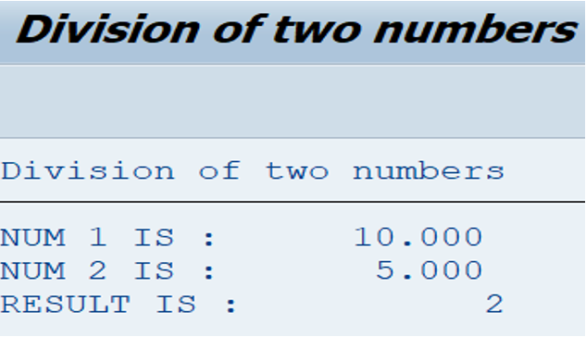

**Assignment 4 – Business Add in (BADI)-Multiple Use**

**Hint:**

1. **SE18 should be used to define a BADI**

2. **SE19 should be used to implement the BADI Definition.**

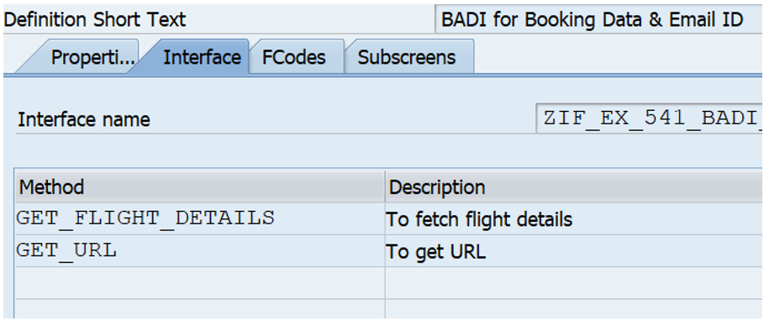

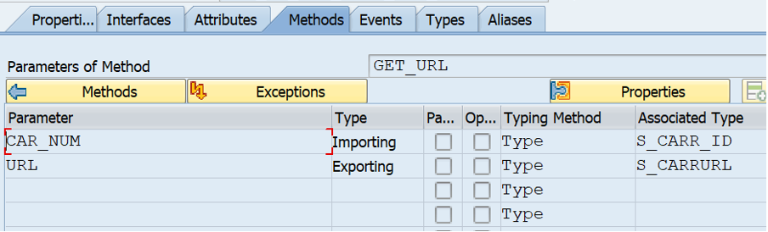

**CODE:**

*&---------------------------------------------------------------------*  
*& Report Z249_BADI_DAY10_Q3  
*&---------------------------------------------------------------------*  
* Description:                                                         *  
*                                                                      *  
* Author:                                                              *  
*                                                                      *  
* Create date:                                                         *  
*                                                                      *  
*&---------------------------------------------------------------------*  
* Modification log:                                                    *  
* -------------------------------------------------------------------- *  
* Date        User name      ID       Change Request   Case ref.       *  
*             Description                                              *  
*&---------------------------------------------------------------------*  
REPORT Z249_BADI_DAY10_Q3.  
  
DATA LV_IF TYPE REF TO Z249_BADI_INTERFACE.    "Reference object declaration for Interface  
  
DATA RESULT TYPE INT4.                          "Variable for result  
  
PARAMETERS: NUM1 TYPE INT4,                     "Parameter for 1st number  
            NUM2 TYPE INT4.                     "Parameter for 2nd number  
  
CL_EXITHANDLER=>GET_INSTANCE(  
  EXPORTING  
    EXIT_NAME                     = 'Z249_BADI_DEMO'    " BADI Definition  
  CHANGING  
    INSTANCE                      =  LV_IF   "Interface Instance  
  EXCEPTIONS  
    NO_REFERENCE                  = 1  
    NO_INTERFACE_REFERENCE        = 2  
    NO_EXIT_INTERFACE             = 3  
    CLASS_NOT_IMPLEMENT_INTERFACE = 4  
    SINGLE_EXIT_MULTIPLY_ACTIVE   = 5  
    CAST_ERROR                    = 6  
    EXIT_NOT_EXISTING             = 7  
    DATA_INCONS_IN_EXIT_MANAGEM   = 8  
    OTHERS                        = 9  
).  
IF SY-SUBRC <> 0.  
ENDIF.  
  
LV_IF->DIVIDENUMBERS(  
  EXPORTING                                                                       "Sending the 2 numbers to the method for calculation  
    I_NUM1                  =   NUM1  " First number  
    I_NUM2                  =   NUM2  " Second number  
  IMPORTING                                                                       "Receiving the result from the method  
    E_RESULT                =   RESULT   " Natural number  
  EXCEPTIONS  
    OTHERS                  = 2  
).  
IF SY-SUBRC = 1.  
  MESSAGE 'Division with zero is undefined' TYPE 'E'.  
ENDIF.  
  
WRITE:/ 'Result is : ',RESULT.                            "Printing the result

**OUTPUT:**

